TASK 1, DATE = 10/1/25

1. Query all columns for all American cities in the **CITY** table with populations larger than 100000. The **CountryCode** for America is USA. The **CITY** table is described as follows:

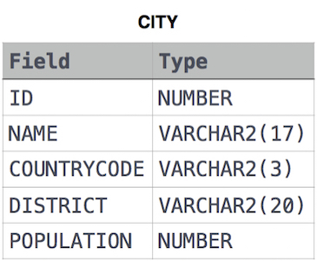

**Solution:**

SELECT * FROM CITY

WHERE COUNTRYCODE='USA' AND POPULATION > 100000;

--------------------------------------------------------------------------------------------------------------------------------------

1. Query the NAME field for all American cities in the CITY table with populations larger than 120000. The *CountryCode* for America is USA. The CITY table is described as follows:



**Solution:**

SELECT NAME FROM CITY

WHERE COUNTRYCODE ='USA' AND POPULATION > 120000;

--------------------------------------------------------------------------------------------------------------------------------------

1. Query all columns (attributes) for every row in the CITY table. The CITY table is described as follows:



**Solution:**

SELECT * FROM CITY

1. Query all columns for a city in CITY with the *ID* 1661. The CITY table is described as follows:



**Solution:**

SELECT * FROM CITY WHERE ID = 1661;